I/Savory Garlic Marinated Steaks(2 servings)(source: [Savory Garlic Marinated Steaks Recipe | Allrecipes](https://www.allrecipes.com/recipe/17325/savory-garlic-marinated-steaks/))

1. ½ cup balsamic vinegar
2. ¼ cup soy sauce
3. 3 tablespoons minced garlic
4. 2 tablespoons honey
5. 2 tablespoons olive oil
6. 2 teaspoons ground black pepper
7. 1 teaspoon Worcestershire sauce
8. 1 teaspoon onion powder
9. ½ teaspoon salt
10. ½ teaspoon liquid smoke flavoring
11. 1 pinch cayenne pepper
12. 1 pound rib-eye steaks

Instructions:

Prep:15 mins

Cook:15 mins

Servings:2

Step 1

In a medium bowl, mix the vinegar, soy sauce, garlic, honey, olive oil, ground black pepper, Worcestershire sauce, onion powder, salt, liquid smoke, and cayenne pepper.

Step 2

Place steaks in a shallow glass dish with the marinade, and turn to coat. For optimum flavor, rub the liquid into the meat. Cover, and marinate in the refrigerator for 1 to 2 days.

Step 3

Preheat grill for medium-high to high heat.

Step 4

Lightly oil the grill grate. Grill steaks 7 minutes per side, or to desired doneness. Discard leftover marinade.

II/Sweet, Sticky and Spicy Chicken(4 servings) (source: [Sweet, Sticky and Spicy Chicken Recipe | Allrecipes](https://www.allrecipes.com/recipe/143082/sweet-sticky-and-spicy-chicken/))

1. 1 tablespoon brown sugar
2. 2 tablespoons honey
3. ¼ cup soy sauce
4. 2 teaspoons chopped fresh ginger root
5. 2 teaspoons chopped garlic
6. 2 tablespoons hot sauce
7. salt (depend your taste)
8. pepper (depend your taste)
9. 1 tablespoon vegetable oil
10. 4 skinless (2 pounds) boneless chicken breast halves

Instructions:

Prep:10 mins

Cook:12 mins

Total:22 mins

Servings:4

Step 1

Mix together brown sugar, honey, soy sauce, ginger, garlic and hot sauce in a small bowl.

Step 2

Lightly salt and pepper the chicken strips.

Step 3

Heat oil in a large skillet over medium heat. Add chicken strips and brown on both sides, about 1 minute per side. Pour the sauce over the chicken. Simmer uncovered until the sauce thickens, 8 to 10 minutes.

III/ Spicy Shrimp (Chingri Maach) (Servings:4)( [Spicy Shrimp (Chingri Maach) Recipe | Allrecipes](https://www.allrecipes.com/recipe/188311/spicy-shrimp-chingri-maach/))

1. 2 tablespoons vegetable oil
2. 2 onions, chopped
3. 1 tomato, chopped
4. 1 teaspoon garlic paste
5. ½ teaspoon ground turmeric
6. ½ teaspoon garam masala
7. 2 green chile peppers, seeded and minced
8. salt to taste
9. 1 pound peeled and deveined shrimp
10. ¼ cup cilantro leaves

Instructions:

Prep: 15 mins

Cook: 20 mins

Total: 35 mins

Servings: 4

Step 1

Heat oil over medium-high heat in a large skillet, and cook and stir onions until golden brown, about 8 minutes. Stir in tomato and cook for 2 minutes. Stir in garlic paste, turmeric, garam masala, green chile peppers, and salt, and cook for 2 minutes more.

Step 2

Reduce heat to low, add the shrimp, and cook and stir over low heat until the shrimp are bright pink on the outside and the meat is no longer transparent in the center, about 8 minutes. Add a small amount of water if needed; the sauce should be thick. Sprinkle with cilantro.

IV/Asian Cucumber Salad(2 servings)(source: [Asian Cucumber Salad Recipe | Allrecipes](https://www.allrecipes.com/recipe/192623/asian-cucumber-salad/))

1. 2 cucumbers - halved lengthwise, seeded, and sliced
2. 2 teaspoons salt
3. ½ cup rice vinegar
4. ¼ cup white sugar
5. 2 tablespoons sesame oil
6. 1 tablespoon minced garlic
7. 1 tablespoon minced fresh ginger root
8. 1 tablespoon sesame seeds
9. 4 fresh red chile peppers, sliced

Instructions:

Step 1

Put the cucumber slices in a colander and sprinkle with salt; set aside to drain for 1 hour.

Step 2

Whisk the vinegar and sugar together until the sugar is dissolved; add the sesame oil, garlic, ginger, and sesame seeds; stir.

Step 3

Rinse salt off the cucumber slices by running under cold water; place in a large bowl with the sliced red chile peppers. Drizzle the dressing over the vegetables and toss to coat. Serve immediately.

V/ Pesto Pizza (source: [Pesto Pizza Recipe | Allrecipes](https://www.allrecipes.com/recipe/21528/pesto-pizza/))

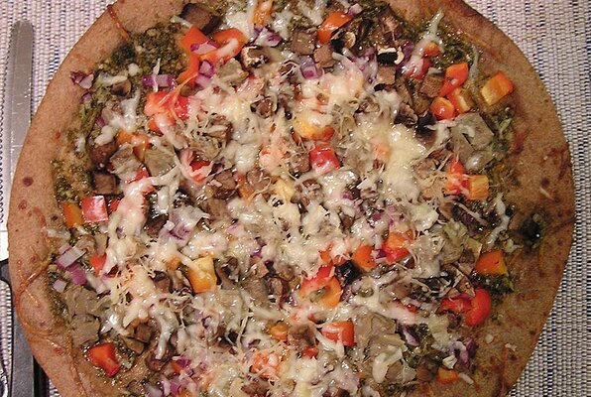

Ingredients:

1. 1 (12 inch) pre-baked pizza crust
2. ½ cup pesto
3. 1 ripe tomato, chopped
4. ½ cup green bell pepper, chopped
5. 1 (2 ounce) can chopped black olives, drained
6. ½ small red onion, chopped
7. 1 (4 ounce) can artichoke hearts, drained and sliced
8. 1 cup crumbled feta cheese

Instructions:

Prep: 10 mins

Cook: 10 mins

Total: 20 mins

Servings: 6

Step 1

Preheat oven to 450 degrees F (230 degrees C).

Step 2

Spread pesto on pizza crust. Top with tomatoes, bell peppers, olives, red onions, artichoke hearts and feta cheese.

Step 3

Bake for 8 to 10 minutes, or until cheese is melted and browned.